Nathan Jorgenson Benefit

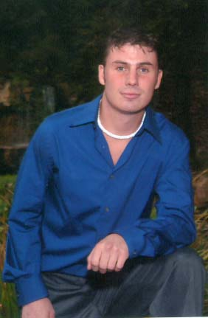

On October 1, 2004 Nathan Jorgenson, a Fort Collins native, had his life changed forever. While walking at night on the sidewalk of South Lemay Avenue, a drunk driver struck him with an SUV and left him in critical condition with a traumatic brain injury and broken cervical vertebrae. He is currently located at Craig Hospital’s Center for Neurological Rehabilitation in Denver where he had fusion surgery for his broken neck. He is now stable with no spinal cord damage, and will be in their care until he returns to Fort Collins on January 20, 2005. Nate will continue his rehabilitation at the Center for Neurorehabilitation Services.

Nate will face many challenges in his recovery, which may last one or more years. He will return to his parents’ home in Fort Collins and will require a wheel chair for an undetermined amount of time. Alterations will need to be made to the Jorgenson home in order to accommodate a new lifestyle, and there will be many expenses that will not be covered by his health insurance.

The person responsible for the accident was arrested and charged with vehicular assault. He did not have a valid driver’s license or insurance on the vehicle so it is unlikely there will be any financial resources outside of Nate’s health insurance.

On January 15, 2005 there will be a benefit for Nate at the County Cork located at 313 West Drake Road in Ft. Collins. This event is being held to raise money to assist Nate and his family meet the costs of the renovation and medical expenses. We are asking local businesses to donate items to be auctioned at the benefit, or cash donations made out to The Nathan Jorgenson Fund. Any contribution you can make, large or small, will help us reach our fund raising goal of $20,000.

We extend you an invitation to join us at the County Cork on January 15, 2005 from 7:00pm to 11:00pm for live music and dancing, with a 30 minute live auction at 8:30pm. A silent auction will also run throughout the evening.

We thank you!

